**PKI LAB 2.0**

Lab Environment Setup: 3

Docker setup: 3

Task 1: Establishing a Certificate Authority (CA) 3

Configuration File: 4

Certificate Authority (CA): 4

Q1: What part of the certificate indicates that this is a CA's certificate? 8

Q2: What part of the certificate indicates that this is a self-signed certificate? 8

Q3: In the RSA algorithm, we have a public exponent e, a private exponent d, a modulus n, and two secret numbers p and q, such that n = pq. Please identify the values for these elements in your certificate and key files. 8

Task 2: Generating a Certificate Request for Your Web Server 10

Generate a CSR for your personal web page 10

Task 3: Generating a Server Certificate 13

Task 4: Deploying Certificate in an Apache-Based HTTPS Website 16

Task 5: Launching a Man-In-The-Middle Attack 19

Task 6: Launching a Man-In-The-Middle Attack with a Compromised CA 20

# Lab Environment Setup:

## Docker setup:

1. Execute the command docker-compose build to construct the container image
2. Initiate the container by using the command docker-compose up (alias dcup)
3. Identify the running containers id name and ip by executing the command dockps

4) For DNS setup, modify the /etc/hosts file by linking www.bank32.com name to the container ip, and the name www.seu.edu.cn to the same container ip, then test the alias name by pinging it.

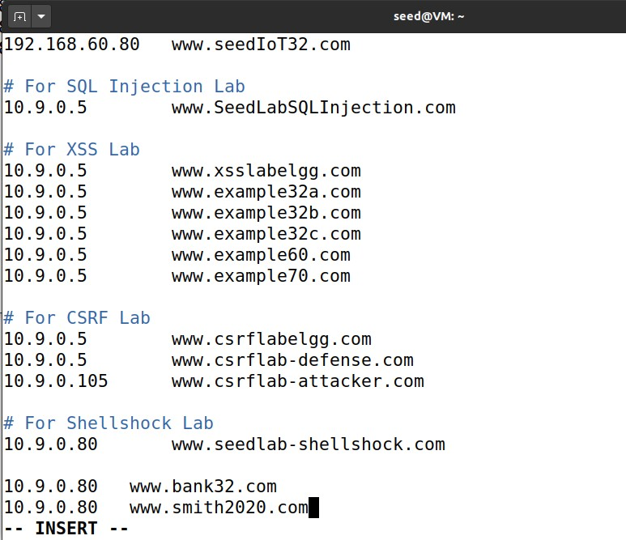

# Task 1: Establishing a Certificate Authority (CA)

The necessary default CA settings to be prepared are as follows:

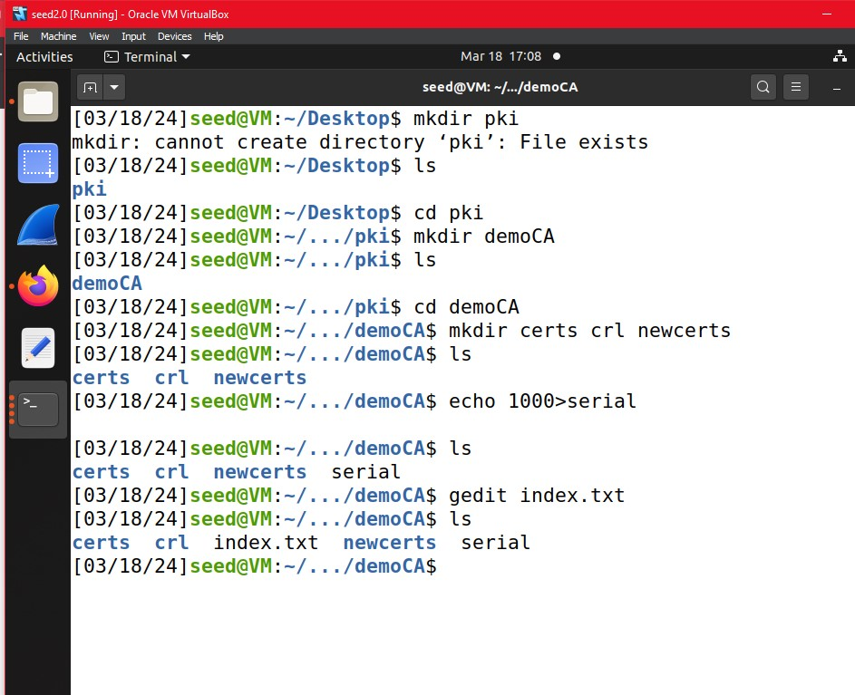

## Configuration File:

To begin, we must copy the openssl.conf file from /usr/lib/ssl/openssl.conf to the PKI folder within which we are operating. To do this, we need to exit the demoCA directory, display the current path, and then execute the copy command.

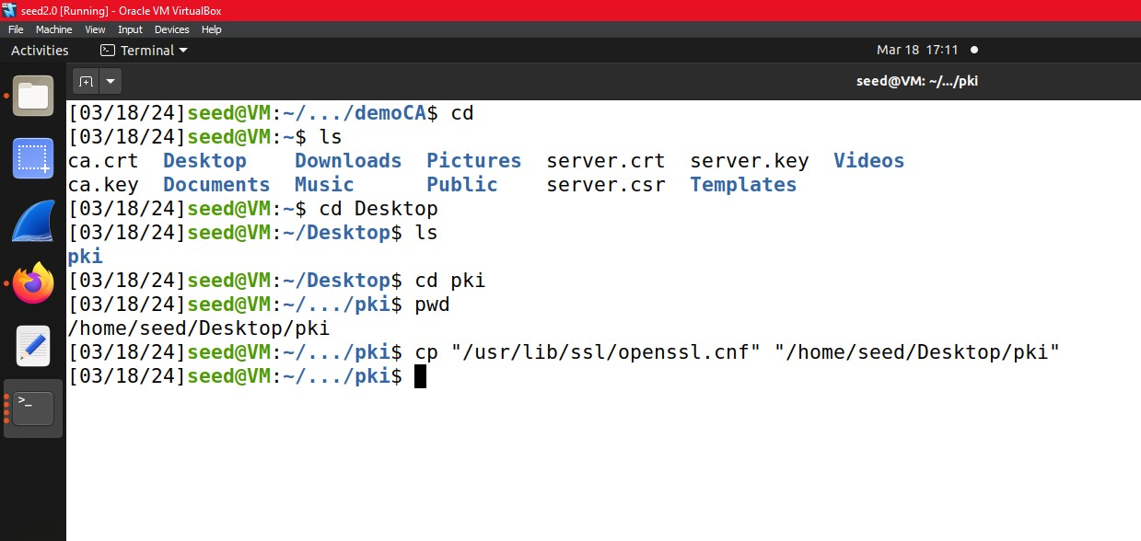

## Certificate Authority (CA):

We use the following commands :

$ openssl req -x509 -newkey rsa:4096 -sha256 -days 3560 -keyout ca.key -out ca.crt -subj “/CN=www.ModelCA.com/O=Model CA LTD. /C=US” -passout pass:dees

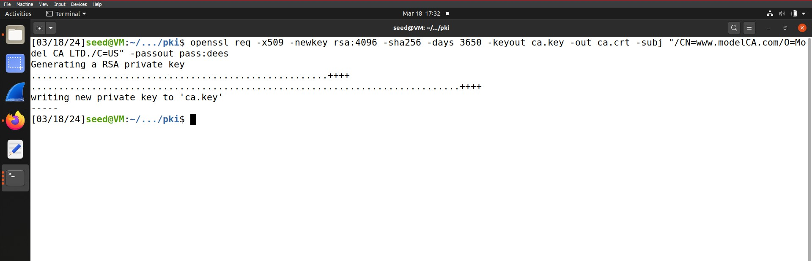

This command is utilized to create self-signed certificates for the Certificate Authority. It verifies the certificate by requesting information pertaining to the certificate. Upon initiating the command, a series of settings need to be configured by adding the CA information to establish the certificate authority.

Meaning of openssl commands:

* req - Generates a signing request.
* -newkey - Creates new requests.
* -x509 - Examines signed certificate by loading x509 modules.
* rsa:4096 - Utilizes RSA key processing command with a key size of 4096.
* -sha256 - Implements SHA-2 256 Message Digest Commands.
* -days 3560 - Indicates that the CA is valid for 10 years (365*10).
* -keyout - Specifies the path and filename where newly created private keys are written.
* -out - Specifies the output file where the result is stored.
* -config - Specifies the configuration file.

To view the decoded certificate, utilize the following command:

$ openssl x509 -in ca.crt -text -noout

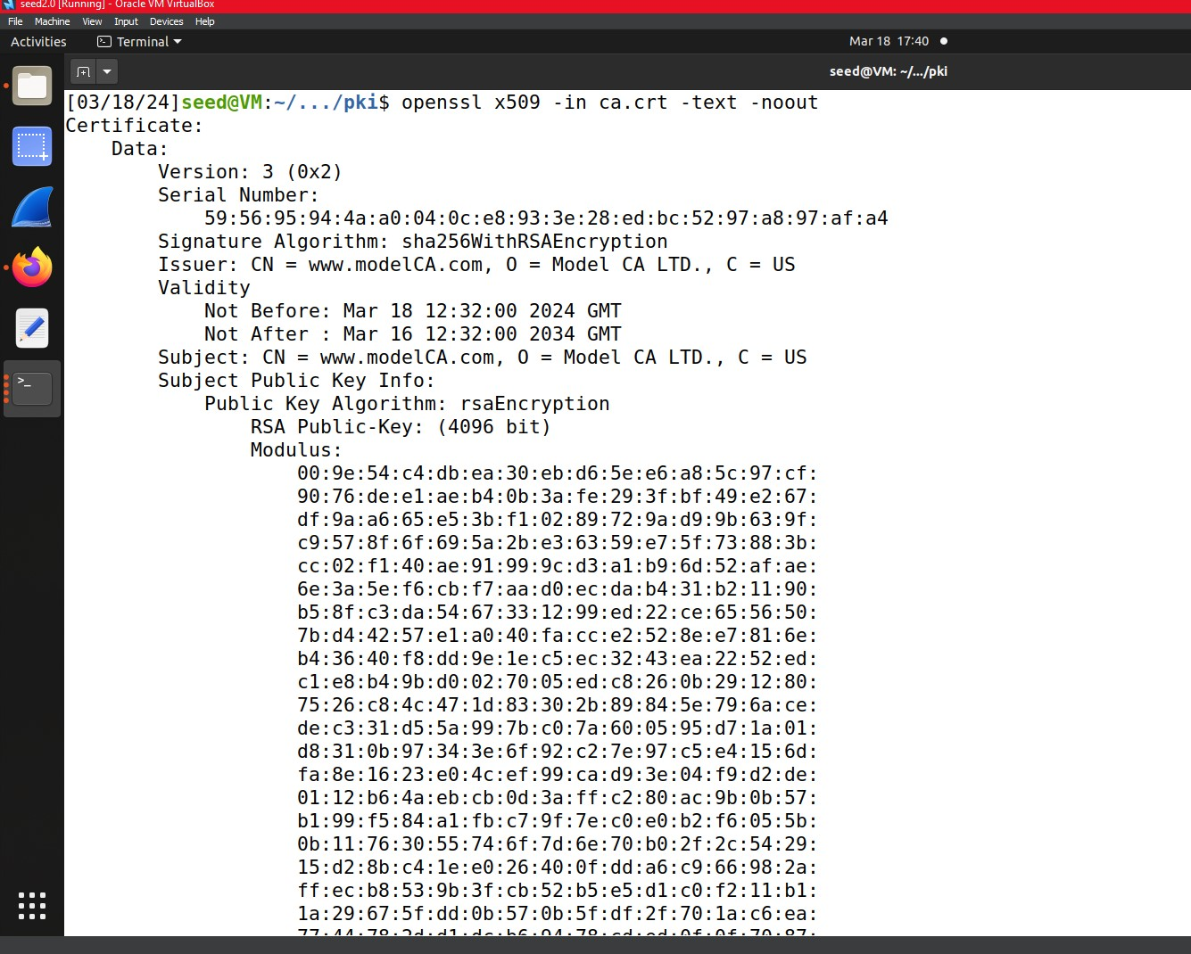

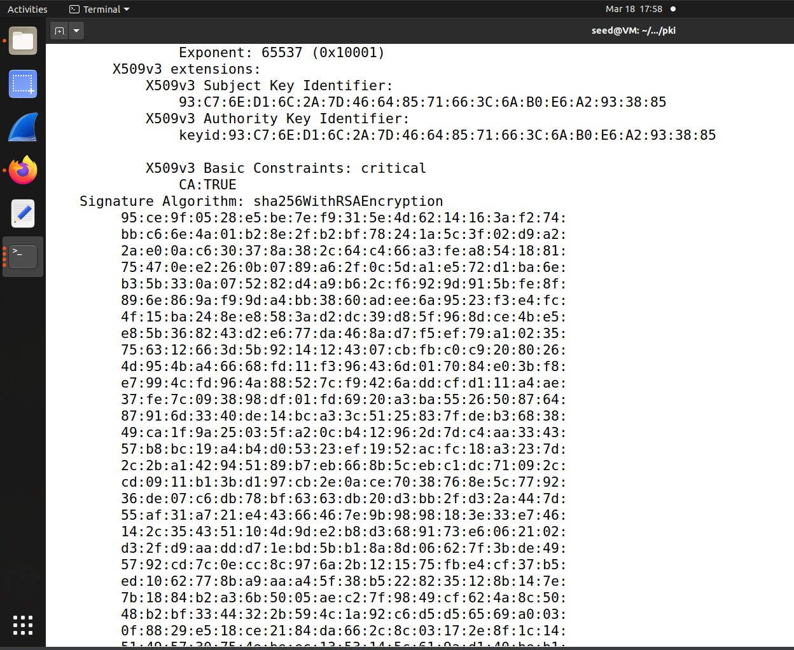

The output displays the following information:

* The Signature Algorithm used
* The dates of certificate Validity
* The Public-Key bit length
* The Issuer, which is the entity that signed the certificate
* The Subject, which refers to the certificate itself

To view the decoded RSA key, you can use the following command: "openssl rsa -in ca.key -text -noout"

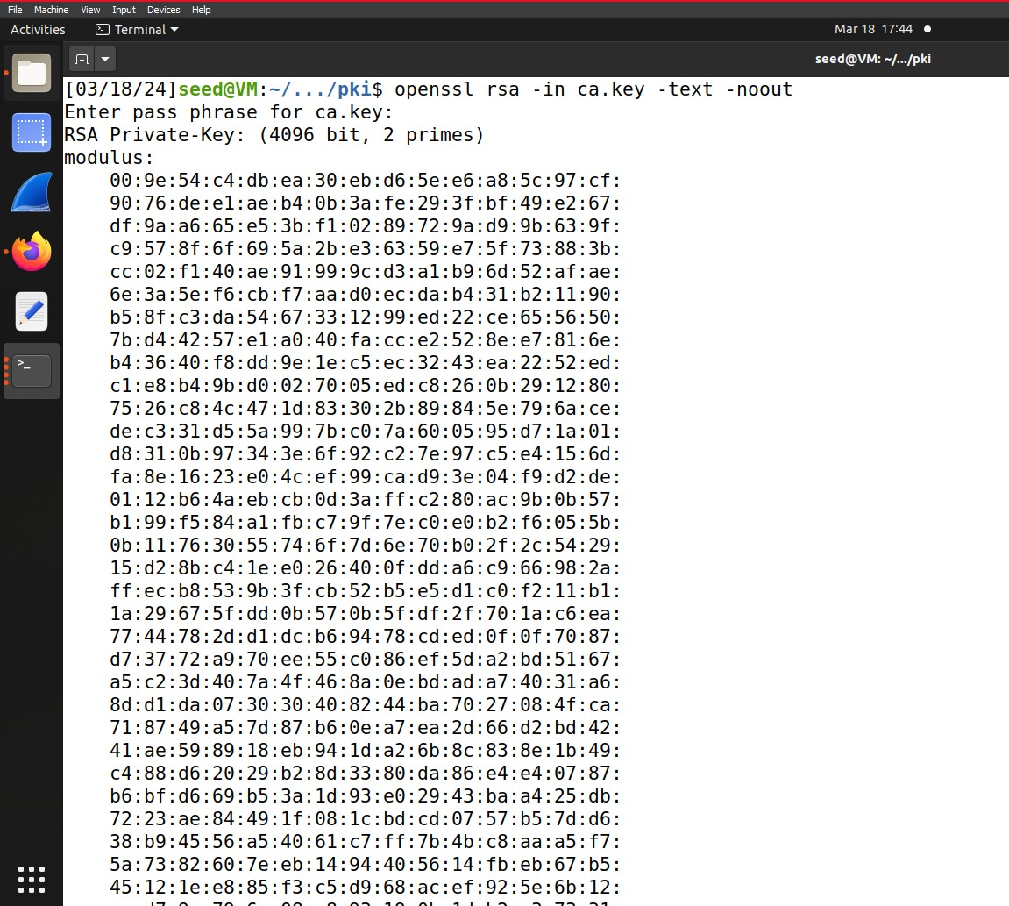



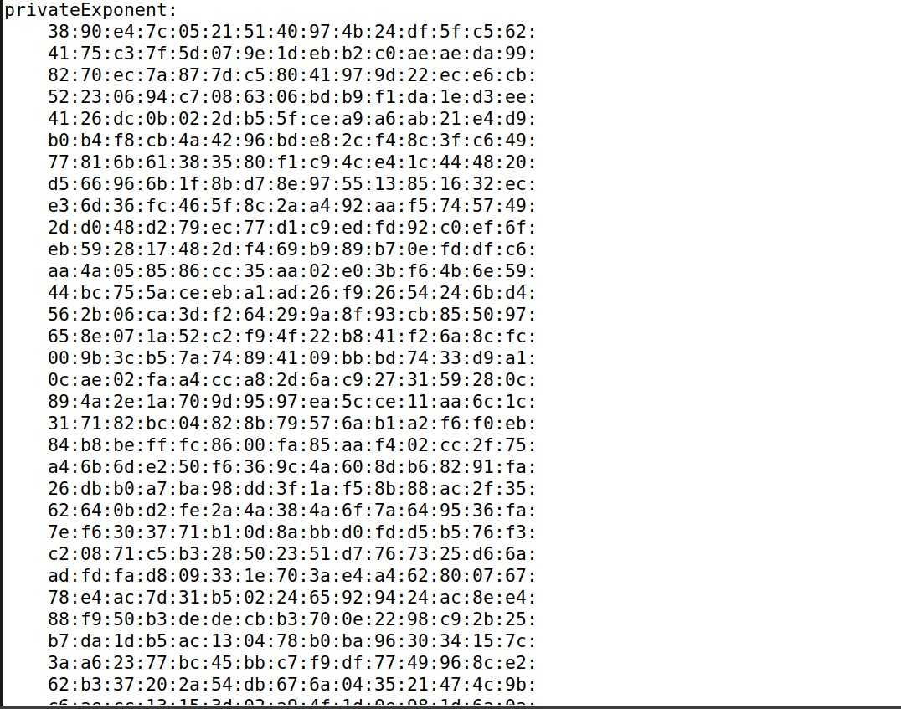

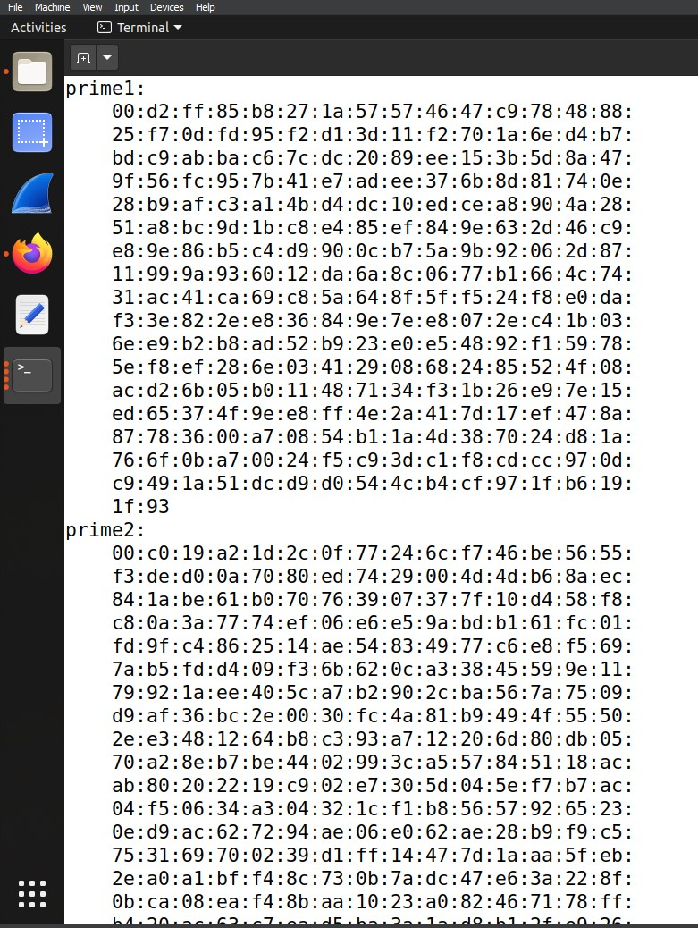

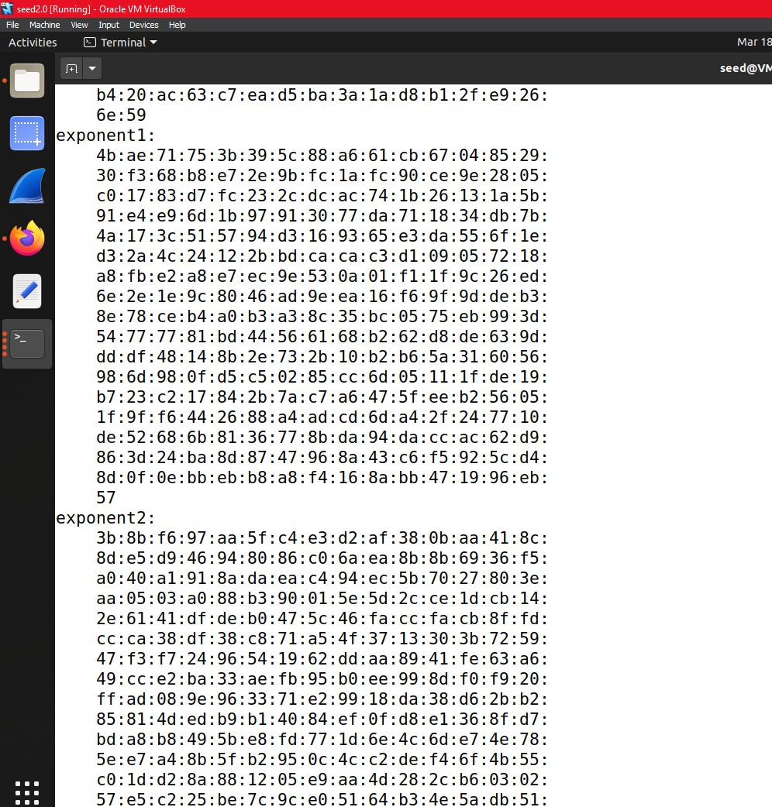

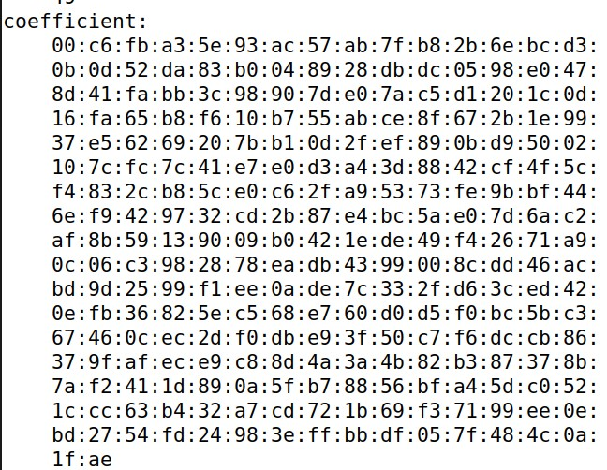

### Q1: What part of the certificate indicates that this is a CA's certificate?

CA: True indicates that this is a certificate authority (CA) certificate. If CA:false, then the certificate is for another entity. Screenshot:



### Q2: What part of the certificate indicates that this is a self-signed certificate?

The Issuer and Subject are identical, indicating that the certificate is self-signed. It is important to note that all root certificates are self-signed.



### Q3: In the RSA algorithm, we have a public exponent e, a private exponent d, a modulus n, and two secret numbers p and q, such that n = pq. Please identify the values for these elements in your certificate and key files.

- modulus: n



- publicExponent: e



- privateExponent: d



- prime1: p and prime2: q



- exponent1: d mod (p-1) and exponent2: d mod (q-1)



- coefficient: (inverse of q) mod p



# Task 2: Generating a Certificate Request for Your Web Server

## Generate a CSR for your personal web page

In this task, we need to generate a certificate signing request (CSR) for our company. In the docker configuration, we add an alias for the container, which is "www.bank32.com," representing a fake company server for which we want to request the certificate.

$ openssl req -newkey rsa:2048 -sha256 -keyout server.key -out server.csr -subj "/CN=www.bank32.com/O=bank32 Inc./C=US" -passout pass:dees

Screenshot:

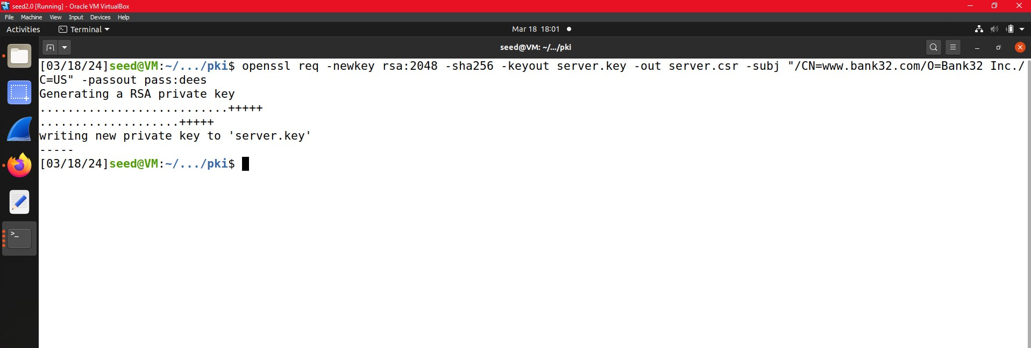

The output consists of a pair of public and private keys. To view the decoded CSR, you can use the following command: "openssl req -in server.csr -text -noout"

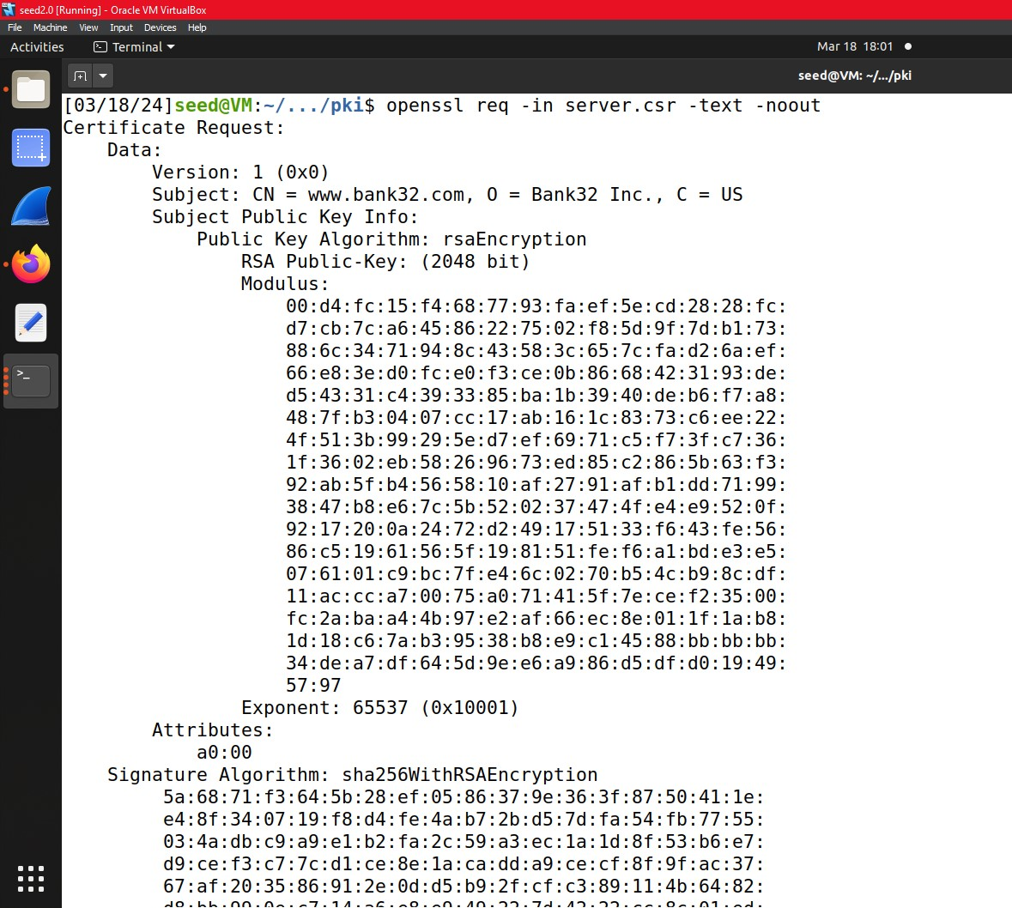

To view the decoded private key, you can use the following command: $openssl rsa -in server.key .

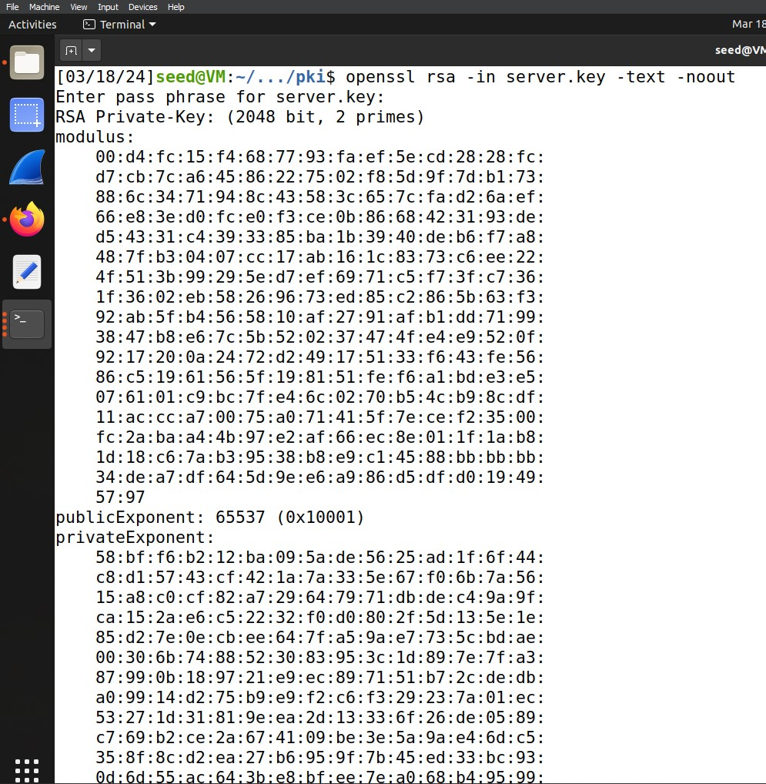

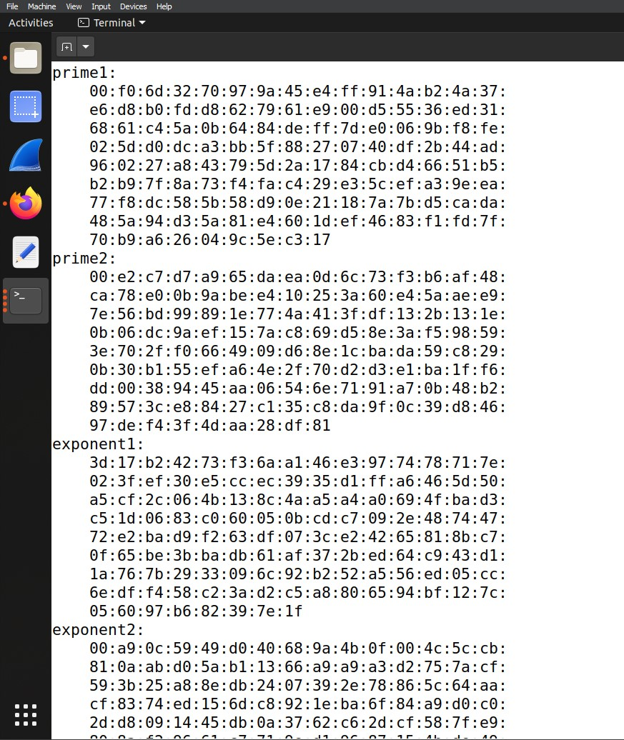

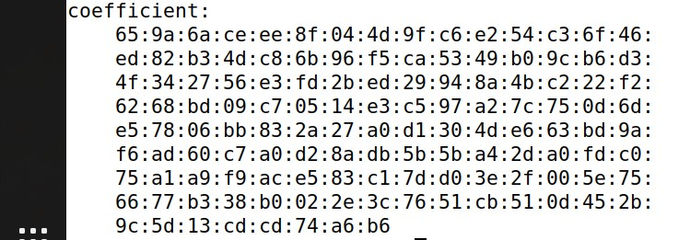

Now we will add alternatives using the commands following

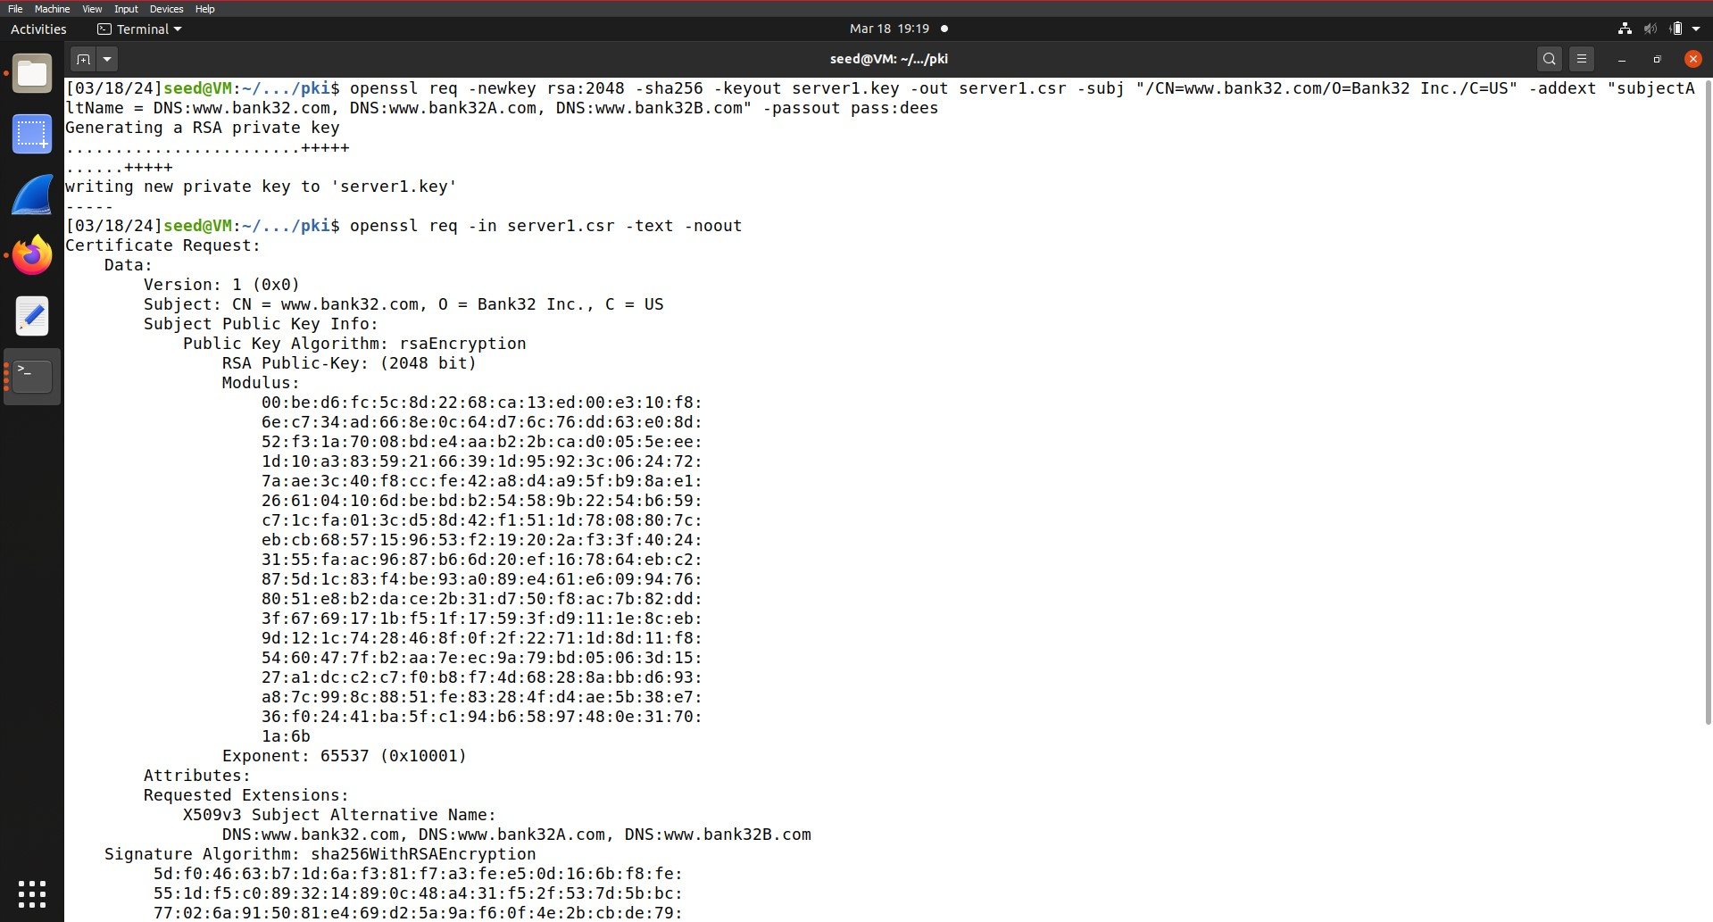

We do this by adding -addext “subjectaltname=DNS:www.bank32.com, DNS:www.bank32A.com, DNS:www.bank32B.com” to the existing command. Then we can display the alternatives as shown above.

# Task 3: Generating a Server Certificate

Before starting, please follow these steps:

1) Uncomment line 68 command to copy the extension field from the request to the final certificate.

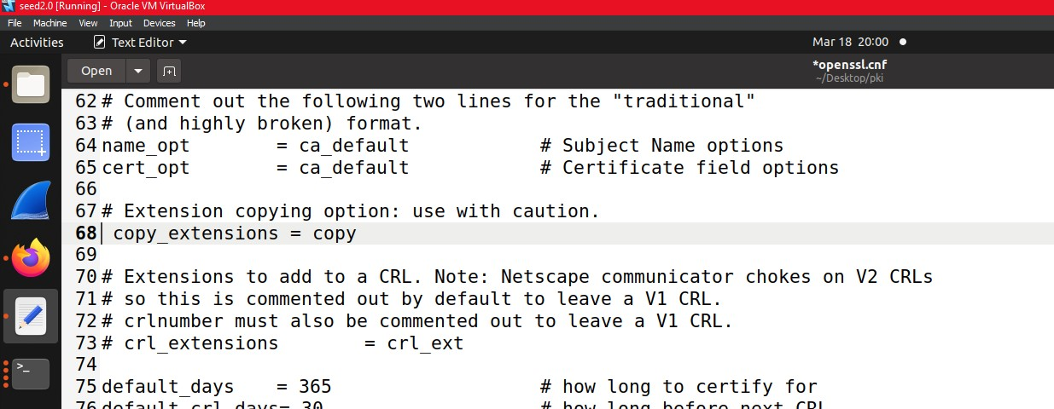

1. Uncomment line 49 command to allow the creation of certificates with the same subject by using a unique subject line.

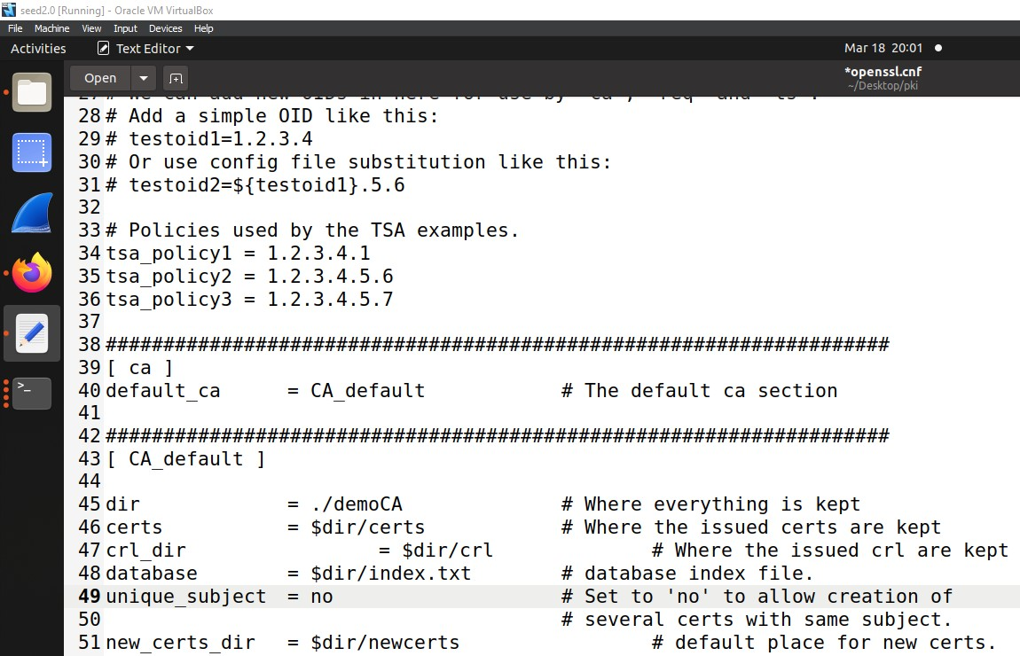

**Observation:**

The index.txt.attr file is automatically created by adding the unique subject configuration with "no".

3) Make sure to use the policy anything policy defined in the configuration file.

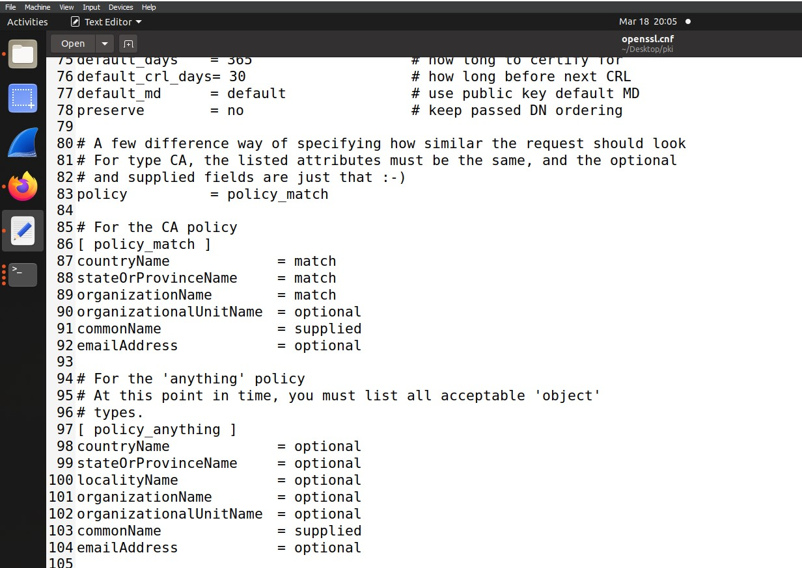

To create the certificate, use the following command:

$ openssl ca -config openssl.cnf -policy policy_anything -md sha256 -days 3650 -in server.csr -out server.crt -batch -cert ca.crt -keyfile ca.key

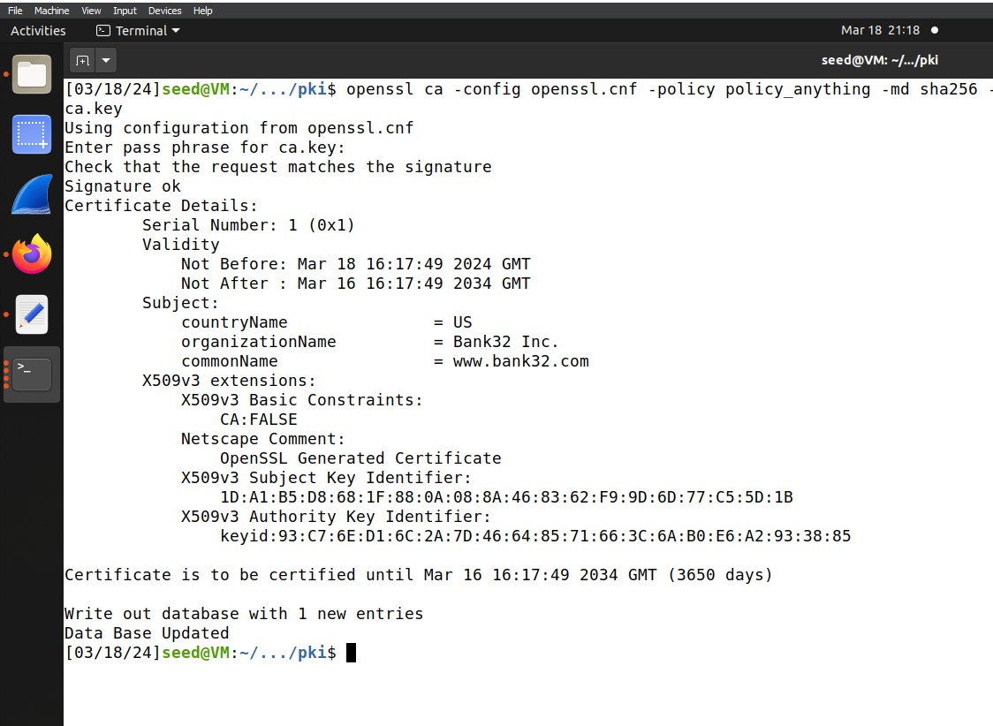

**Observation:**

The serial file value is increased by 1 for the next record, and the index.txt file is updated with the new certificate information.

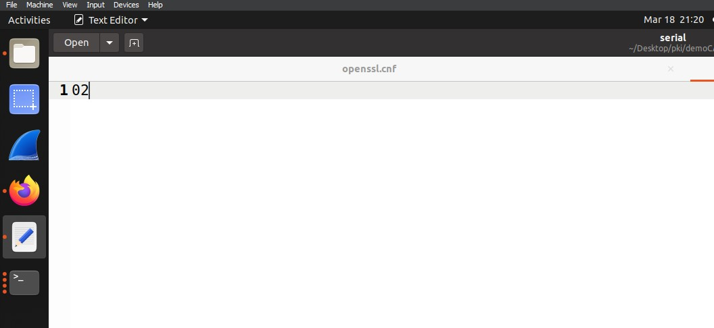

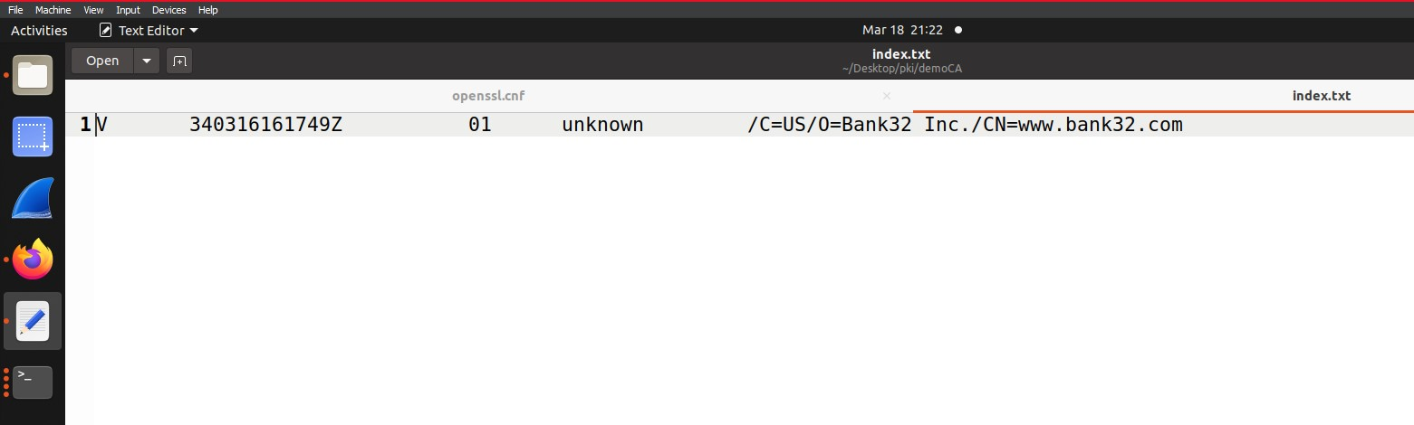

To view the certificate, use the following command:

$ openssl x509 -in server.crt -text -noout

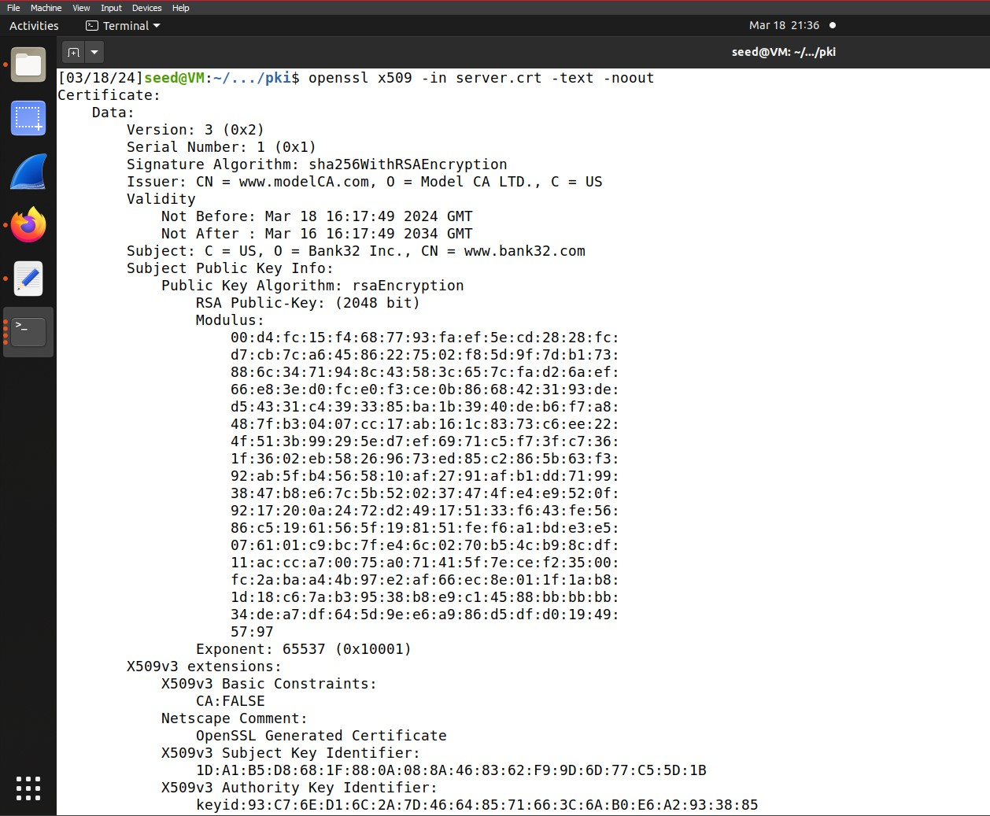

# Task 4: Deploying Certificate in an Apache-Based HTTPS Website

For this task we will follow the steps written below,

1) Update the Apache SSL configuration file.

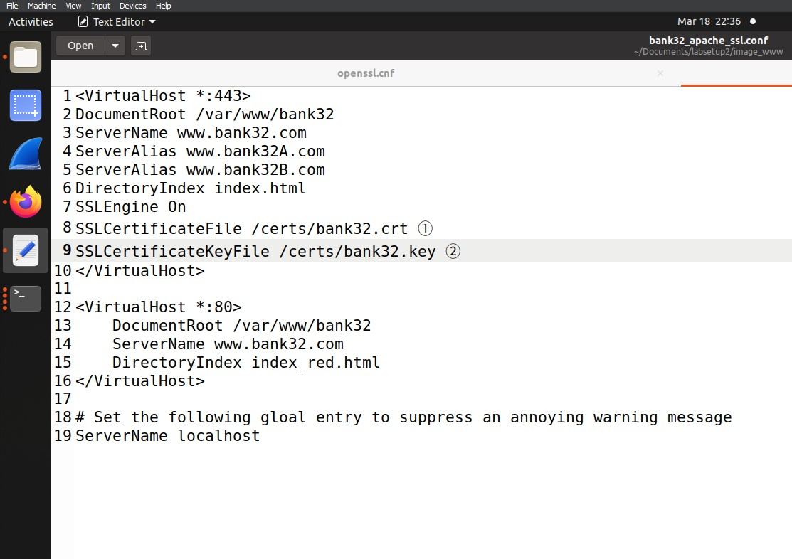

Update the configuration host file of the Bank32 file to match our site names, certificate/key files for port 443, and the indices files for both HTTPS (port 443) and HTTP (port 80).

2) Get the container ID, run the Docker container, enable our site, and restart the Apache2 server.

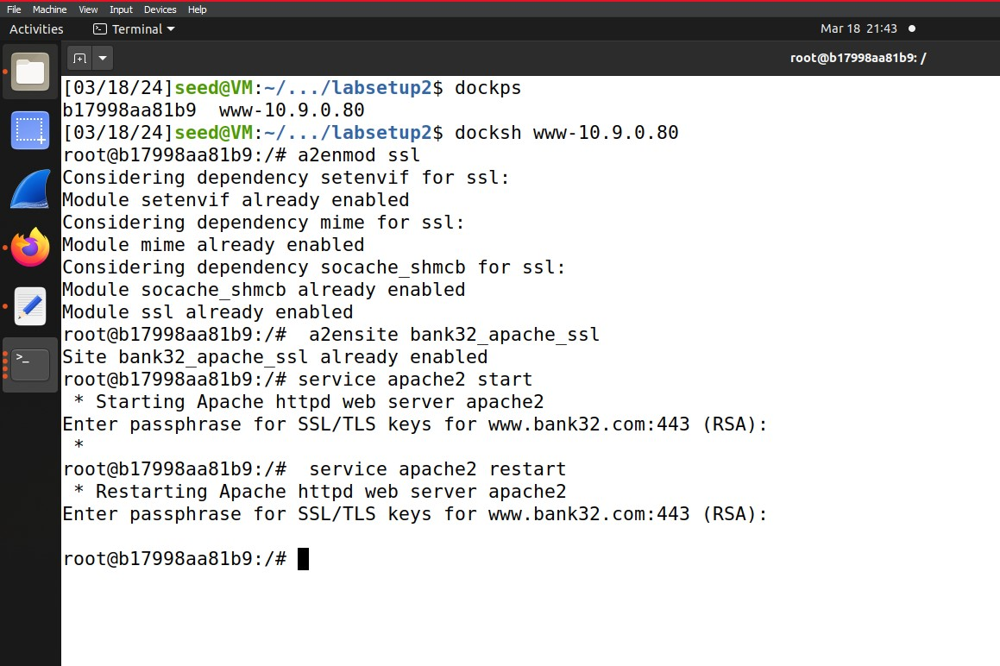

3) Ensure that the necessary files are copied to the required destination after building the container.

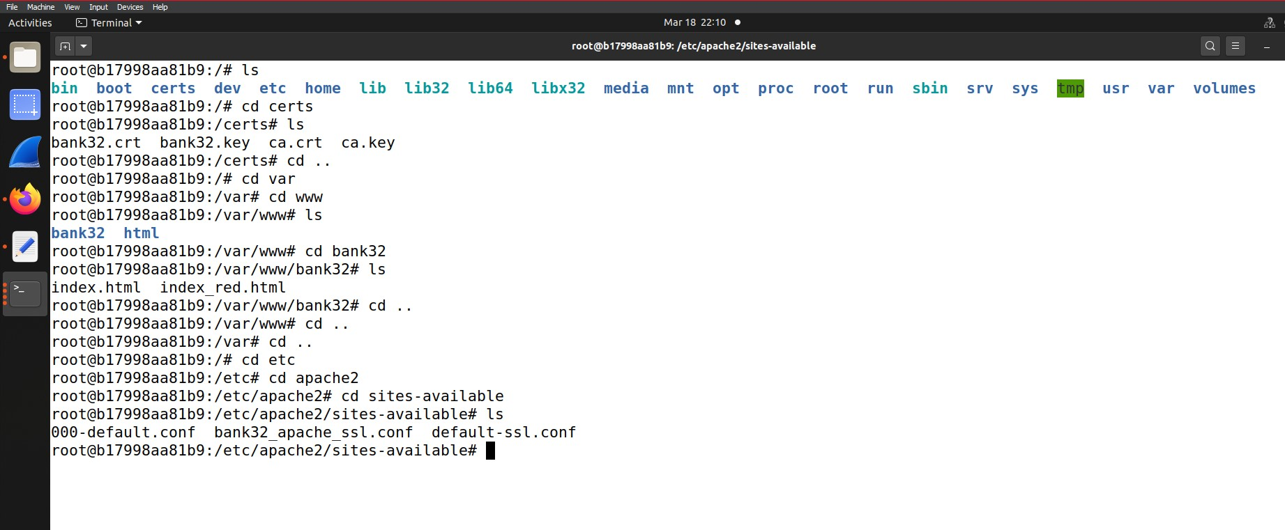

1. When opening our site using the HTTPS protocol, the website may not open due to a security issue. This is because the root CA was created by ourselves, and the browsers do not trust it. To resolve this, we need to manually add the certificate file to the browser's CA.

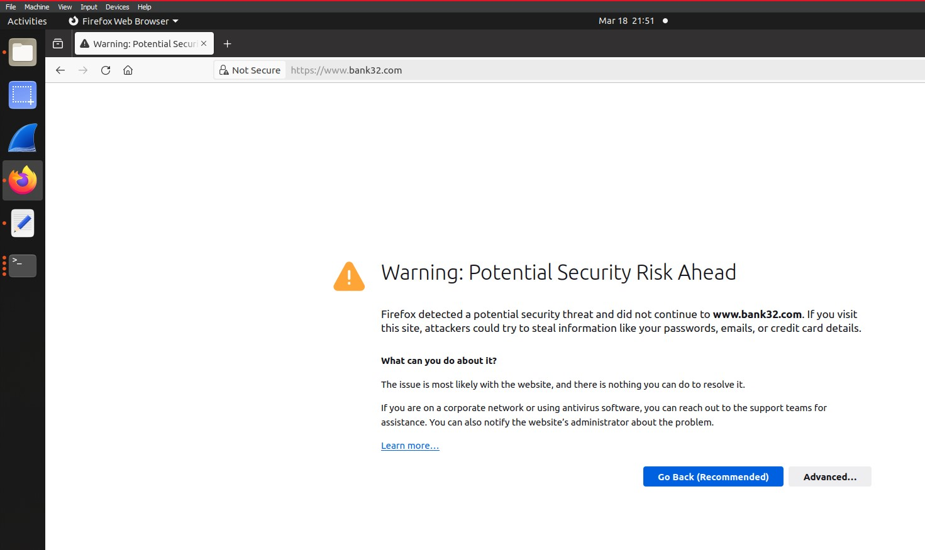

**Step 1:** Go to "Privacy and Security" in the Firefox browser either by typing the path address or by going to "Edit" -> "Preferences".

**Step 2:** Go to "Certificates" -> "View Certificates".

**Step 3:** Go to "Authorities".

**Step 4:** Click "Import" to add our CA authority.

**Step 5:** Choose the CA public key file (ca.cert) that was generated in task 1.

**Step 6:** Opt for "Trust the CA to identify websites" and review the certificate authority details.

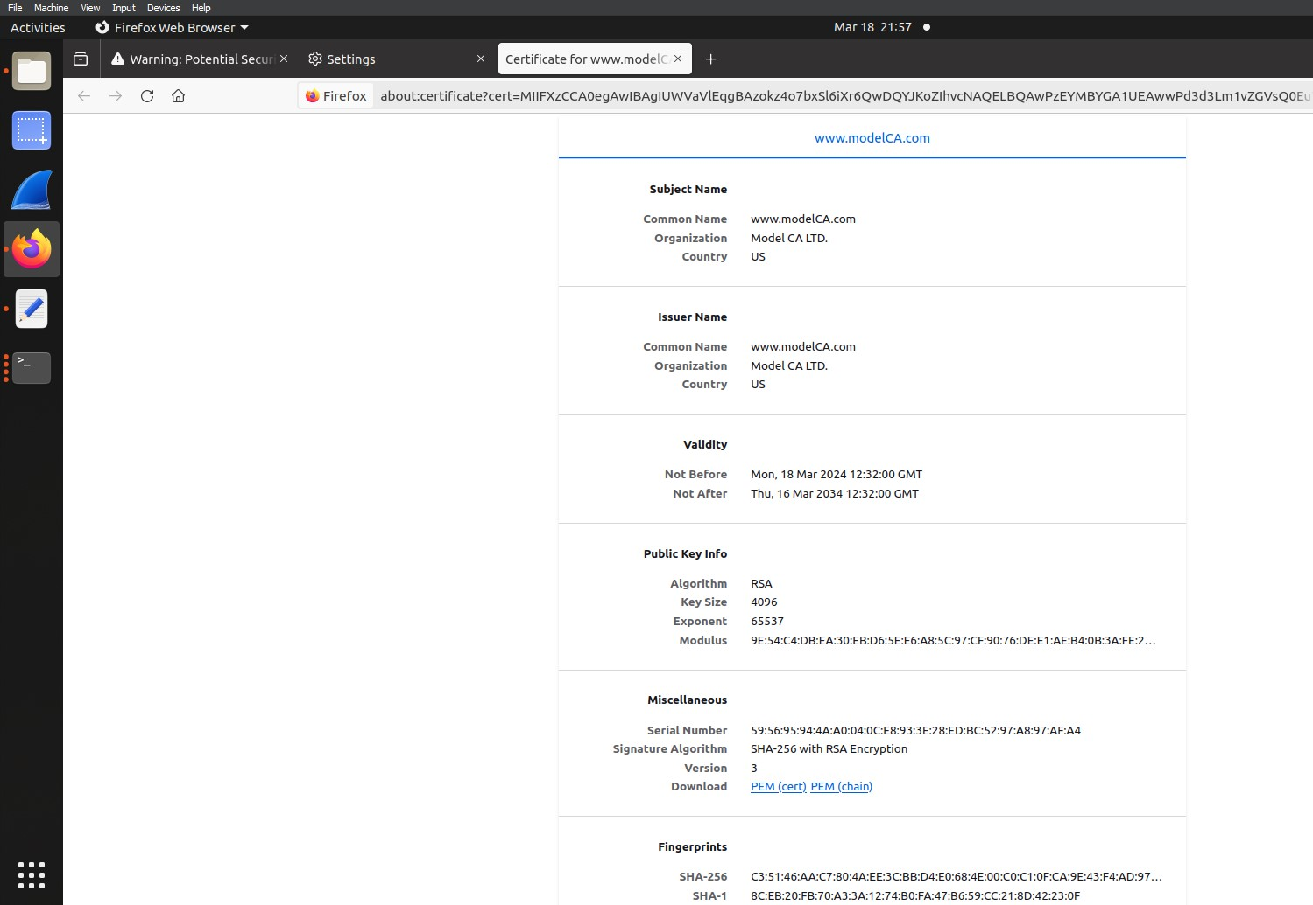

**Step 7:** Verify that the CA has been included.

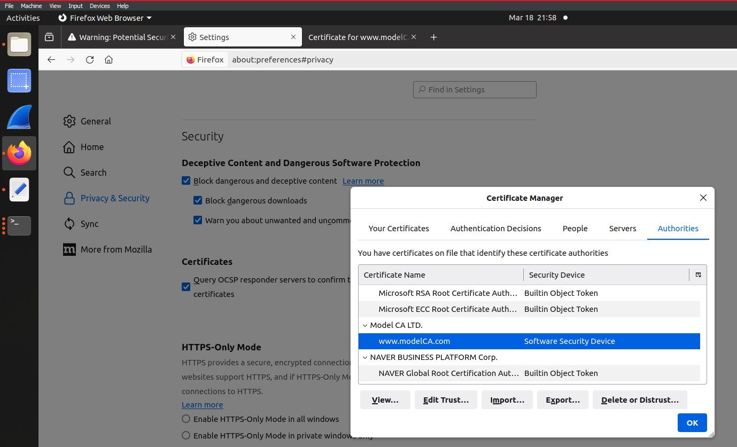

**Step 8:** Close the browser and then reopen our website using https. This time, the website is considered trustworthy by the CA as it has been signed by the CA.

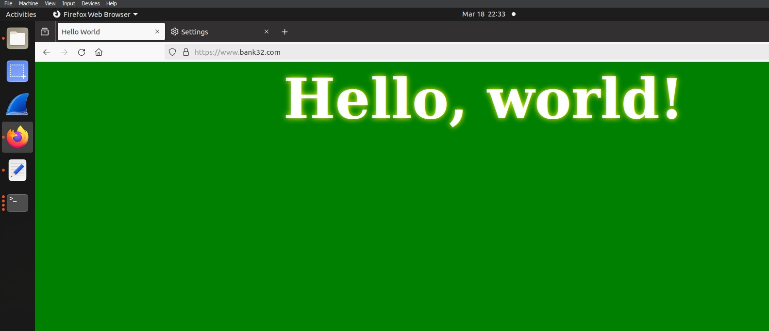

# Task 5: Launching a Man-In-The-Middle Attack

In this task we used a existing website of southeast university where we tried to hijack it by adding the website to the host file with the dockers ip address as following,

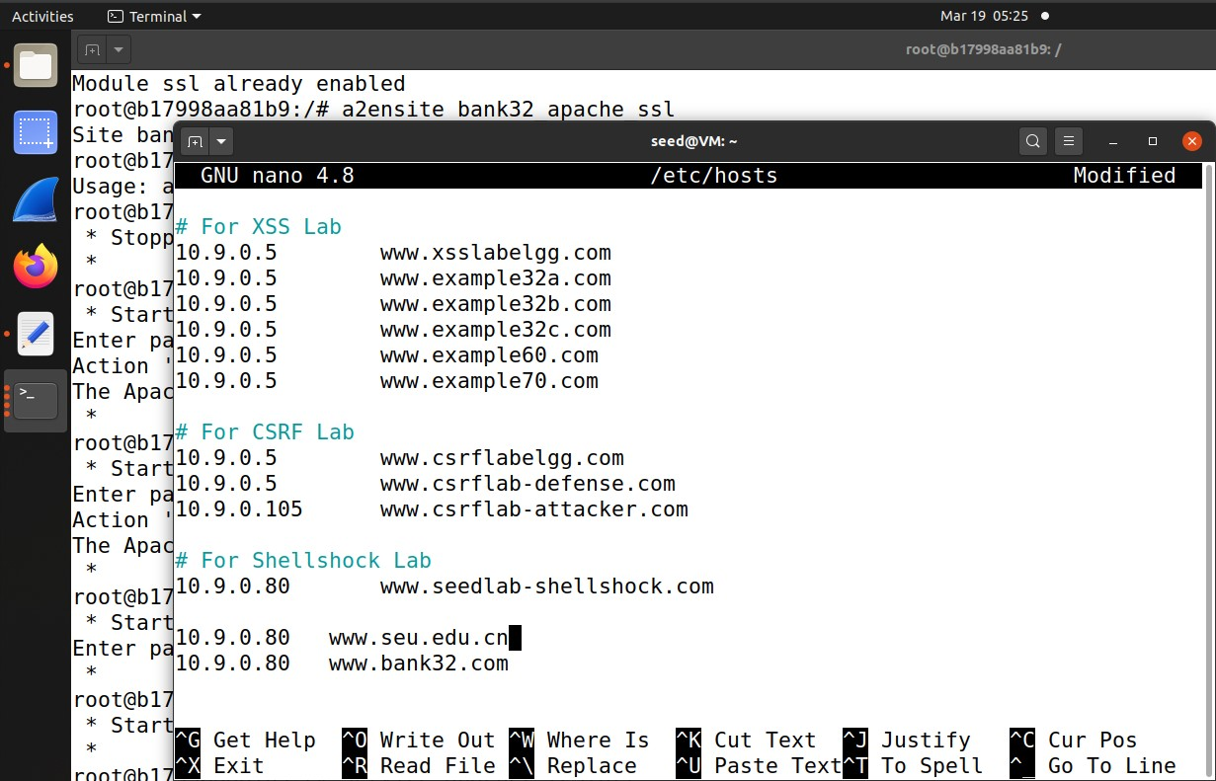

Then we tried to access the website

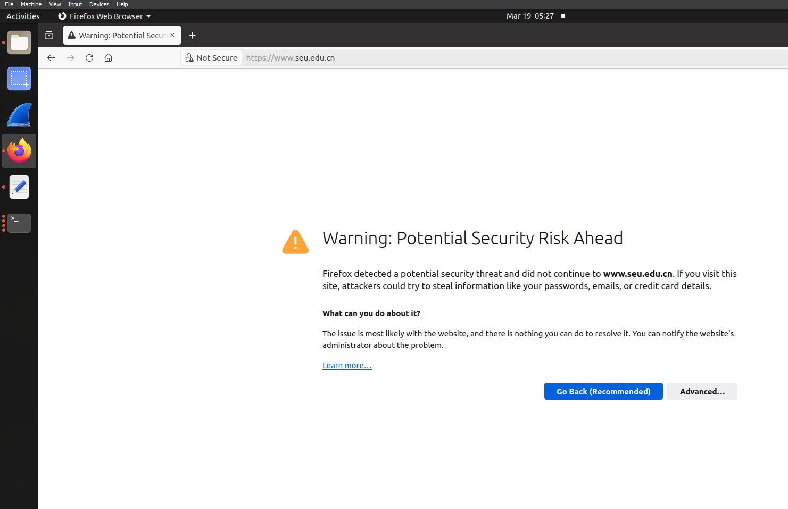

Here we can see the website generates an error if we try to access it declaring a security threat. This due to non verified certificate.

# Task 6: Launching a Man-In-The-Middle Attack with a Compromised CA

In this task we try to attack using a compromised certificate using the following method,

**Step 1:**

In this step we generate the fake certificates for the website using the following commands,

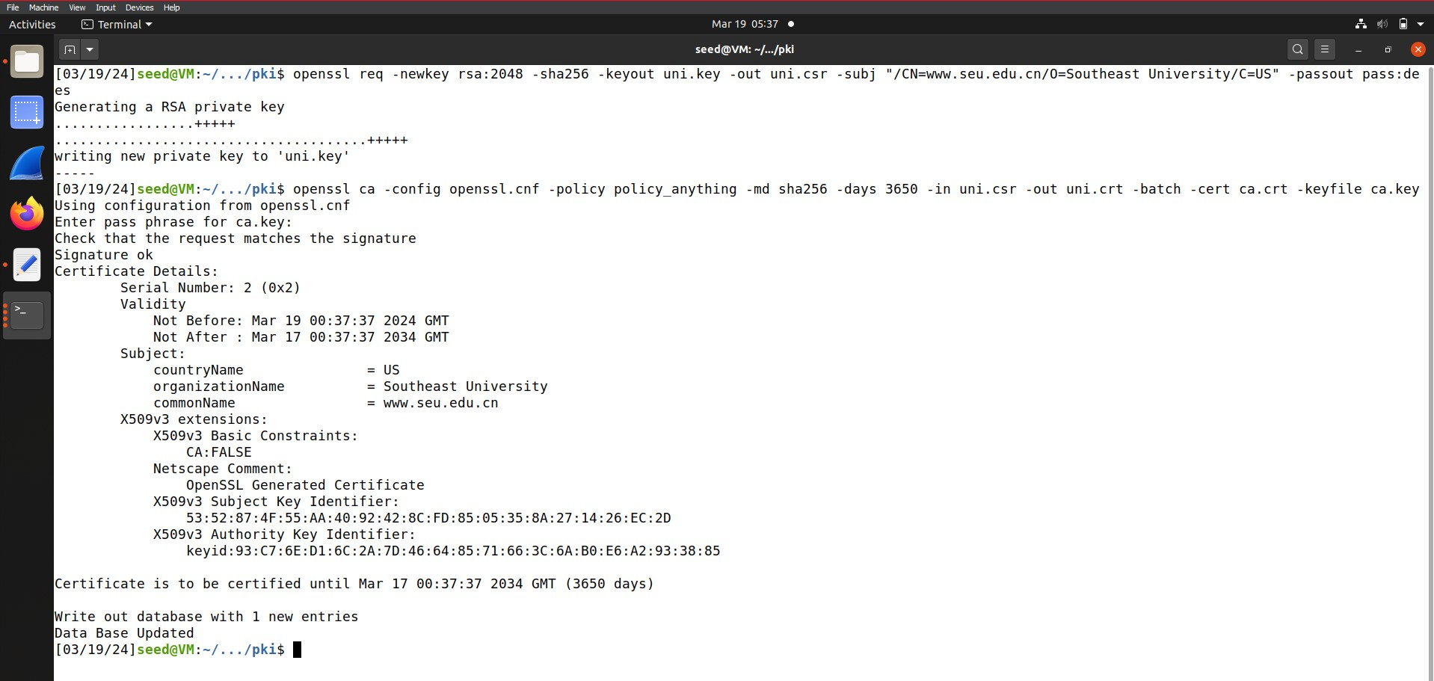

**Step 2:**

In the next step we create the configuration file for the website as shown in the following picture below,

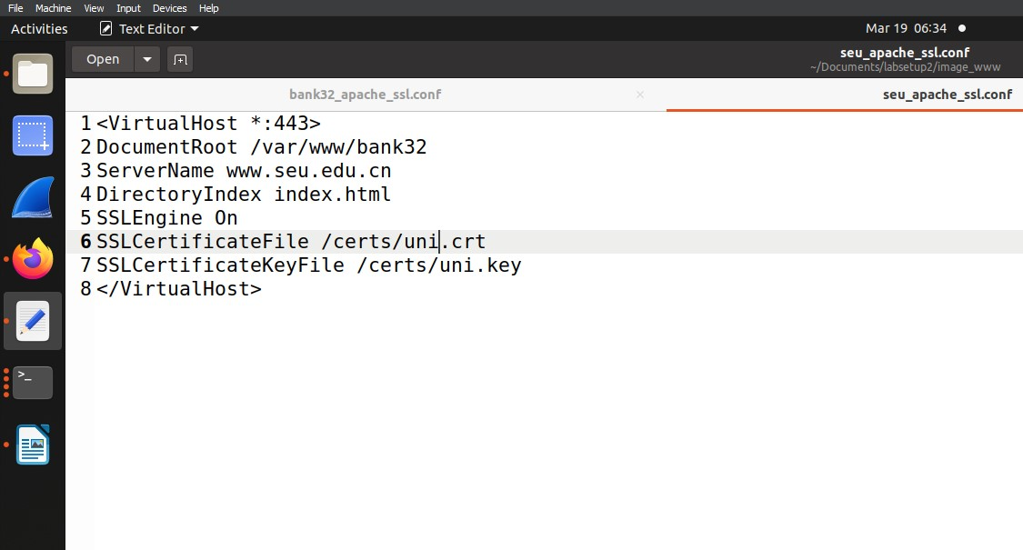

**Step 3:**

For the next step we look at the docker file. Here we will make the necessary changes that are required for website to work with compromised ca.

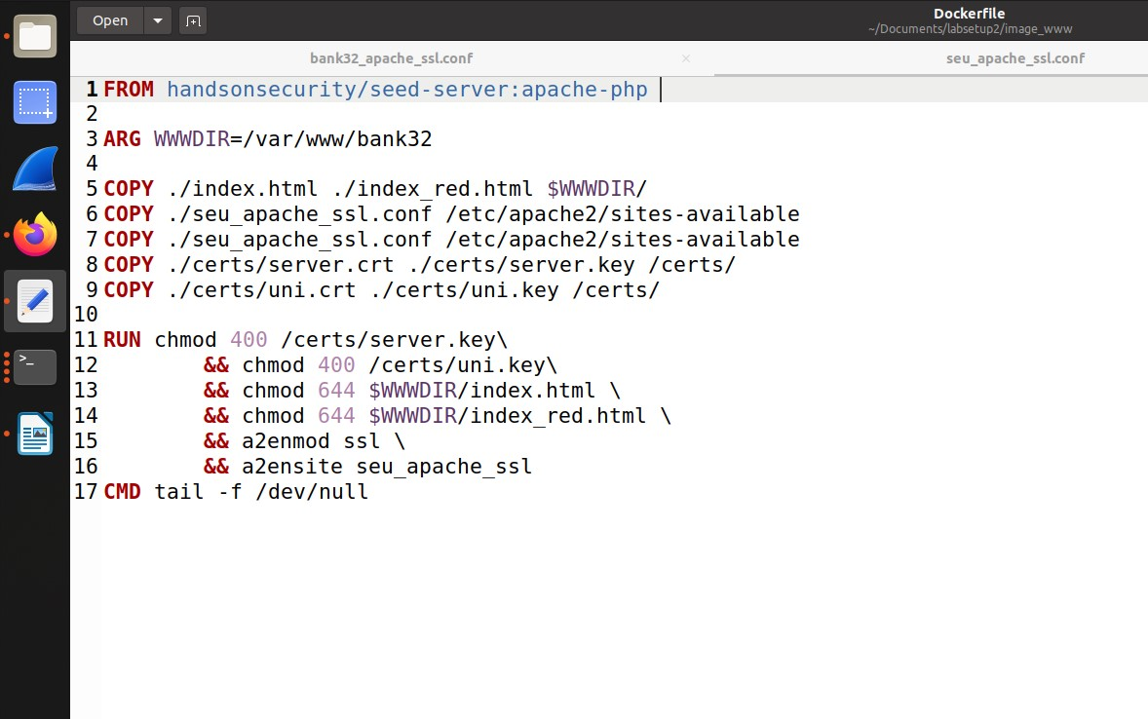

**Step 4:**

In this step of the task we will run dcbuild and dcup to compile the docker and start it.

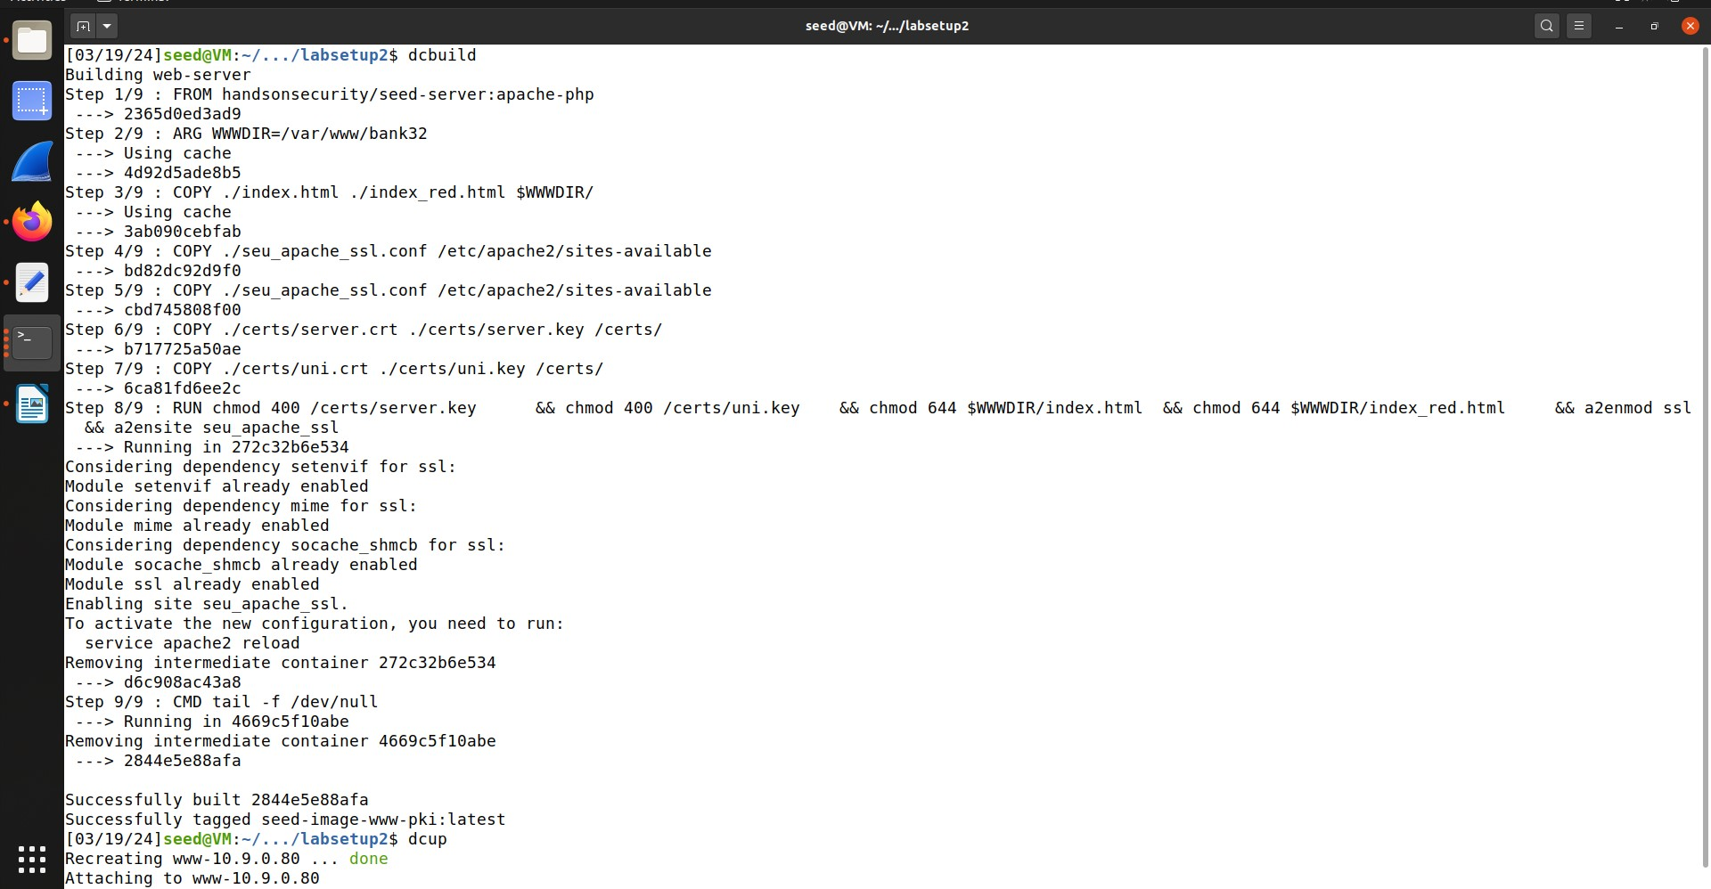

**Step 5:**

In this step we run the container and use apache start command to start the apache server in the container.

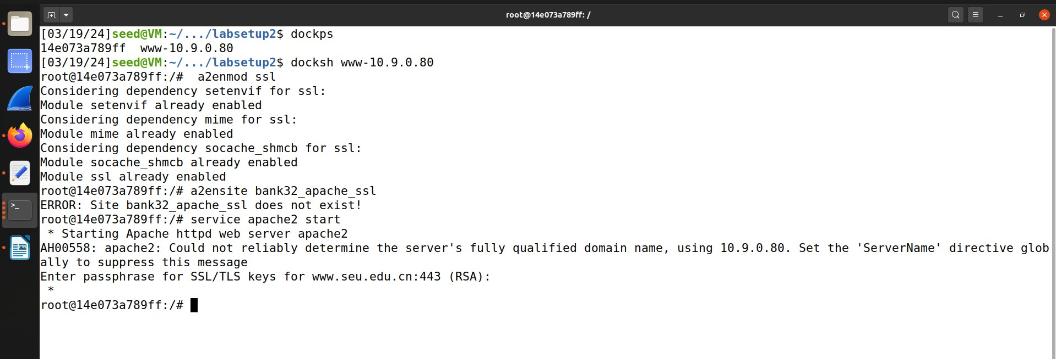

**Step 6:**

In this step we will access the website to see what happens,

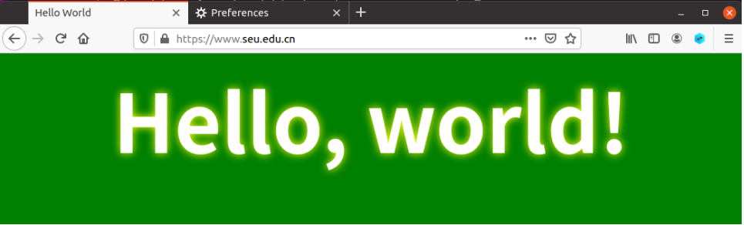

Here we can see that website is successfully loaded.